Home Quiz 4

By: Kyle Martinez, Amar Maharaj, Bradley Zarek

Mobile Apps for Google Android

# MODS App

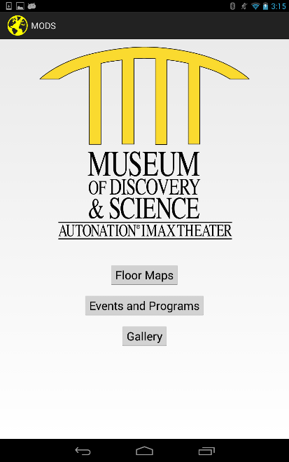

According to the specifications set in the AndroidManifest.xml the application will load the edu.fau.mods.modsapp.MainMenu class upon startup. From this point the user is given the option to load other activities by clicking on one of the three available button views: “Floor Maps”, “Events and Programs”, or “Gallery”.

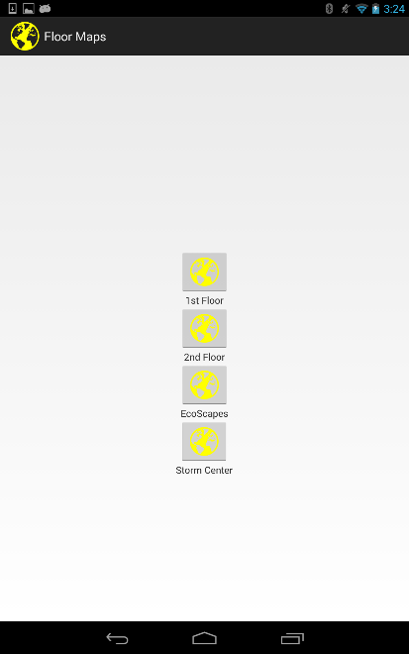

Having clicked on “Floor Maps” we are now presented with the corresponding activity (edu.fau.mods.modsapp.FloorMap), in which we are given button options listing the various museum floors.

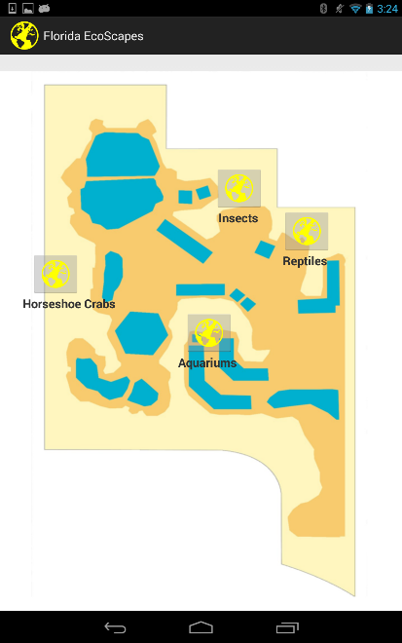

Clicking on the EcoScapes button has now loaded another activity. From here we can specify exhibits of particular interest.

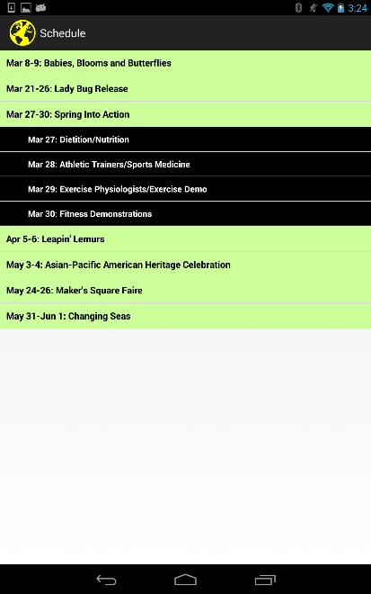

The MODS application also contains a schedule menu. The schedule is created in code by instantiating an ExpandableListView, populating it with “parent” events, then populating the parents with “child” events. From there the view object is added to the activity, so that the user may interact with it.

# Integration App

As the camera moves closer to a green object the value returned by the program becomes greater, and greater. However, increasing the distance between the camera and the object will result in the returned value becoming lesser, and lesser. Another noteworthy feature of the program is the usage of bitwise operators to perform a right shift on the color values for red and green.

